Technical specification

DMEE CGI modifications

Date:
29/02/2024

Version number:
1.0
HISTORY

Revision history
Version | Date | Status | Author
1.0 |  | Initial version | Nicolas Ménard

Distribution
Version | Date | Name | Title

Approvals
Version | Date | Name | Title | Signature

TABLE OF CONTENTS
1 Functional specifications 4
1.1 Bank number 4
1.2 Beneficiary name modification 4
2 Technical specifications 6
2.1 Bank number modification 6
2.2 Beneficiary name modification 6
2.3 Technical implementation 6

Functional specifications

Bank number
In the XML payment file, the system adds the bank key in the case that the bank number is not available. This leads to rejects as the bank key is an internal key and has no meaning for the bank. The code behind the tag <MmbId> must be modified: if no bank number, leave empty.

Beneficiary name modification
Societé Generale requires that the vendor name field is limited to 35 characters, which is set in the tag. However, quite regularly, names are longer. The name1 field in the vendor master data is 40 characters and it can happen that there a continuation in the Name2 field. If the name is not complete in the payment file, the bank rejects the payment. This is obviously an issue.
After several discussion with the bank, they indicated that the remaining part of the name should be added to the address line of the beneficiary. I don’t think that this is a very ‘clean’ solution but we asked confirmation by giving examples and they insist.
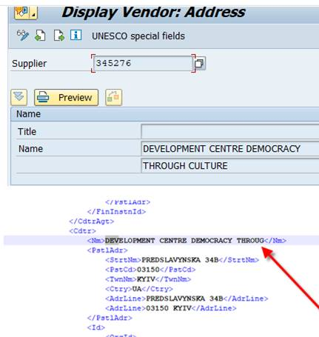
The above example should be added in the file as follow:
<Nm>: DEVELOPMENT CENTRE DEMOCRACY THROUG
<StrtNm>: H CULTURE PREDSLAVYNKA 34B
We will need to adapt the coding, of the user exit, FI_CGI_DMEE_EXIT_W_BADI, and indicate to:
strtNm should contain Name1 (position 35-40) and Name2 (1-40) but only if there is something filled
Then the rest should be street address. From what I can see, there is no limit in the nr of characters for the street address. Just a general limit for the complete address of 150characters (country included).

Technical specifications

Bank number modification

XML tags to be modified
- <PmtInf><CdtTrfTxInf><CdtrAgt><FinInstnId><ClrSysMmbId><MmbId>: clear value if no bank number

Beneficiary name modification

XML tags to be modified
- <PmtInf><CdtTrfTxInf><Cdtr><Nm>: Name of beneficiary
Keep only the 35 first character.
- <PmtInf><CdtTrfTxInf><Cdtr><PstlAdr><StrtNm>: Street name
Put the remaining characters of above tag (position 36 to 40) in front of the street address.

Technical implementation
A class (YCL_IDFI_CGI_DMEE_FALLBACK) has been created to manage the requested code. The method GET_CREDIT is called in an extension point at the end of method GET_CREDIT of standard class CL_IDFI_CGI_DMEE_FALLBACK).

